Table of Contents

## PAGE-NO

## CHAPTER 1 INTRODUCTION 2

## CHAPTER 2 PROBLEM BACKGROUND 3

## CHAPTER 3 PROPOSED SYSTEM AND OBJECTIVES 4

## CHAPTER 4 OUTLINE SCREEN DESIGN 6

* 1. **HOME 6**
  2. **ABOUT 6**
  3. **GALLERY 7**
  4. **PROFILE 7**
  5. **LOGIN 8**
  6. **LOGOUT 8**
  7. **REGISTER 9**
  8. **SERVICES 10**
  9. **SHOP 10**

## CHAPTER 5 OUTPUT DESIGN 10

## CHAPTER 6 TESTING 13

**6.1 TEST PLANS 12**

**6.1 TEST CASES 15**

## CHAPTER 7 USER GUIDE 19

## CHAPTER 8 CONCLUSION 21

**CHAPTER 9 REFERENCE 24**

**CHAPTER 10 APPENDIX 25**

**INTRODUCTION**

Welcome to Indoor/Outdoor Plants, your premier destination for all things botanical!

Indoor/Outdoor Plants is more than just a place to shop; it's a celebration of the natural world and its incredible ability to enhance our lives. Whether you're looking to create a serene indoor sanctuary or cultivate a vibrant outdoor oasis, we're here to help you every step of the way.

Step into our virtual garden and discover a diverse array of plants, carefully curated to thrive in a variety of environments. From hardy succulents that require minimal upkeep to elegant flowering plants that add a burst of color to any space, our collection has been thoughtfully selected to cater to your unique tastes and preferences.

But our commitment to you doesn't end with offering exceptional plants. We're passionate about empowering you to become confident and knowledgeable gardeners. That's why we've created a wealth of resources, including comprehensive care guides and expert tips, to ensure that your green companions flourish under your care.

Whether you're a seasoned horticulturalist or a novice with a green thumb, Indoor/Outdoor Plants is your trusted partner in all things botanical. Join us as we embark on this green journey together, where every leaf tells a story of growth and renewal.

Welcome to Indoor/Outdoor Plants, where nature's beauty knows no bounds.

**PROBLEM**

Many individuals who desire to incorporate plants into their indoor or outdoor spaces struggle to find a reliable source that offers a diverse selection of quality plants suitable for their specific needs and environments.

Despite the growing interest in gardening and plant parenthood, there remains a lack of accessible and user-friendly platforms that provide both a wide range of plant options and expert guidance on plant care. As a result, consumers are left feeling overwhelmed and uncertain about which plants to choose and how to properly care for them, leading to frustration and potential disappointment when their plants fail to thrive.

Additionally, for those who lead busy lifestyles or lack the necessary knowledge and experience, the idea of purchasing and maintaining plants may seem daunting and impractical. Without the proper support and resources, many potential plant enthusiasts are deterred from pursuing their interest in greenery, missing out on the numerous benefits that indoor and outdoor plants can offer, including improved air quality, stress reduction, and enhanced aesthetic appeal.

In addressing these challenges, there is a clear opportunity to establish a comprehensive online platform that not only offers a diverse selection of indoor and outdoor plants but also provides valuable guidance and support to help individuals successfully integrate greenery into their lives. By offering curated plant collections, educational resources, and personalized assistance, such a platform can empower customers to confidently embrace the joys of gardening and create thriving green spaces that enrich their daily lives.

**PROPOSED SYSTEM AND OBJECTIVES**

Our proposed system, Indoor/Outdoor Plants, aims to revolutionize the way individuals discover, acquire, and care for plants, both indoors and outdoors. By combining a user-friendly online platform with expert guidance and support, our objectives are as follows:

* Curated Plant Selection: We will offer a diverse and carefully curated selection of indoor and outdoor plants, ensuring that each plant is of the highest quality and suitable for a range of environments and preferences.
* Convenience and Accessibility: We aim to make the process of purchasing and maintaining plants as convenient and accessible as possible, offering easy online ordering, flexible delivery options, and ongoing support from our team of experts.
* Environmental Stewardship: As part of our commitment to sustainability, we will prioritize eco-friendly practices throughout our operations, from sourcing our plants responsibly to minimizing waste and carbon emissions.

Through these objectives, Indoor/Outdoor Plants seeks to empower individuals to embrace the joys of gardening, foster healthier living spaces, and cultivate a deeper connection with the natural world, ultimately enriching lives and communities one plant at a time.

**OUTLINE SCREEN DESIGN**

**Part one**

**I. Header**

**A**. Logo is in the Upper Left side of the webpage

**B.** In the center is the Name of the website which is **Astar**

**C**. The banner is decide the logo and Name and it occupies the whole space there.

D. The link is just below the Banner: Home, About, Gallery, Profile, Login, Logout, Register, Activities, Services, and Video accordingly and each link directs you to its body depending on what link you choose.

**II. Body**

**A. Home**

- Contains the Home, About, Gallery, Profile, Login, Logout, Register, and Activities

**D**. **About**

- A section that provides information about the website, its mission, goals, and the people or organization behind it.

**E**. **Gallery**

- A collection of images files related to the website's content or theme.

**F.** **Profile**

- Optional features that allow visitors to create accounts or profiles on the website, which may provide access to additional content, personalized features, or community interaction.(not interactive yet)

**F. Login**

- a gateway for users to access secure areas of a website that require authentication.

**F. Logout**

- allows users to securely end their current session and log out of their account.

**F.** **Register**

- form where they can create a new account if they don't already have one.

**F.** **Services**

- outlines the products, offerings, or solutions provided by the website owner or organization.

**F. Shop**

- A collection of plants that you can look and buy.

**III. Footer**

The footer contains our names, the creators and when it is created.

H OME PAGE

**OUTDOOR/INDOOR PLANTS**

225*BANNER AND LOGO

`

10*20BUTTONS

100*250BODY

10*200FOOTER

HEADER

B

O

D

Y

FOOTER

Services

About Us

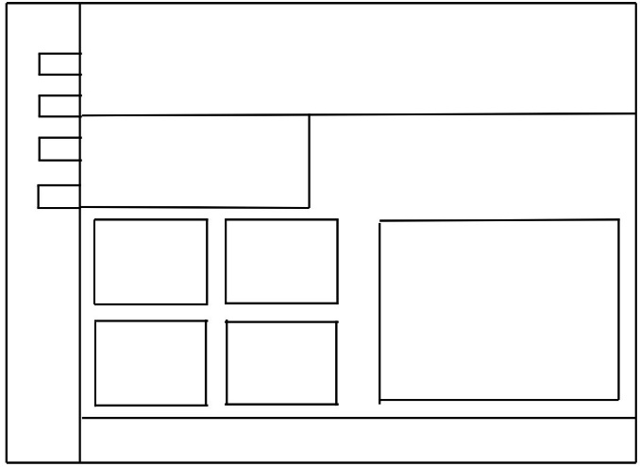 

Logo and Banner

Footer

Text

Buttons

Images

Textbox

Shop

Profile

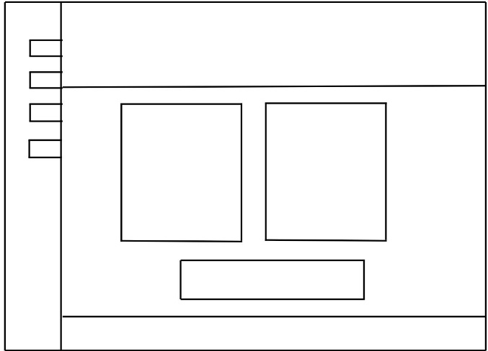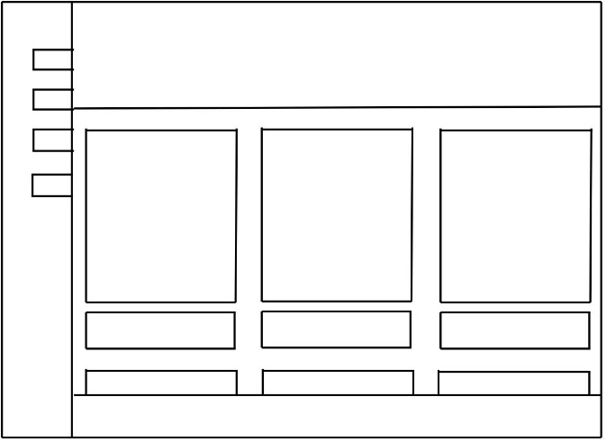

Buy Button

Images

Profile Info

Profile Picture

Register

Login

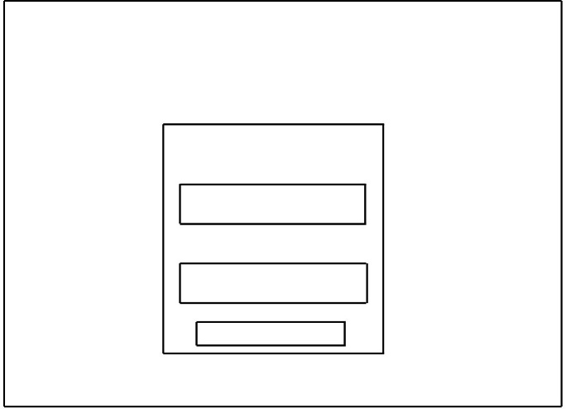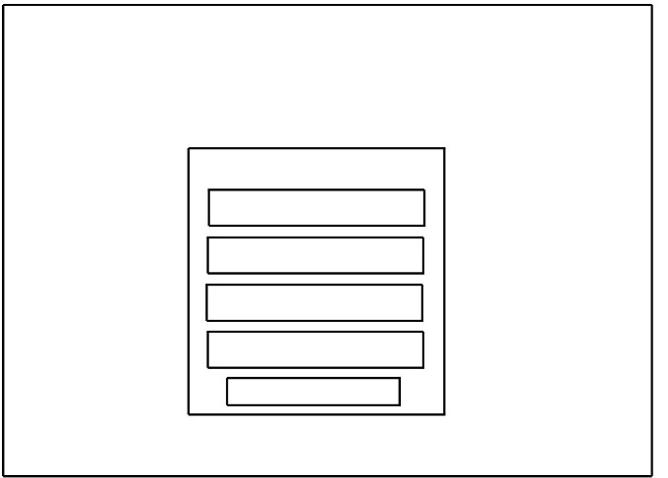

Submit Button

Submit Button

Input Type

Input Type

**OUTPUT SCREEN DESIGN**

HOME PAGE

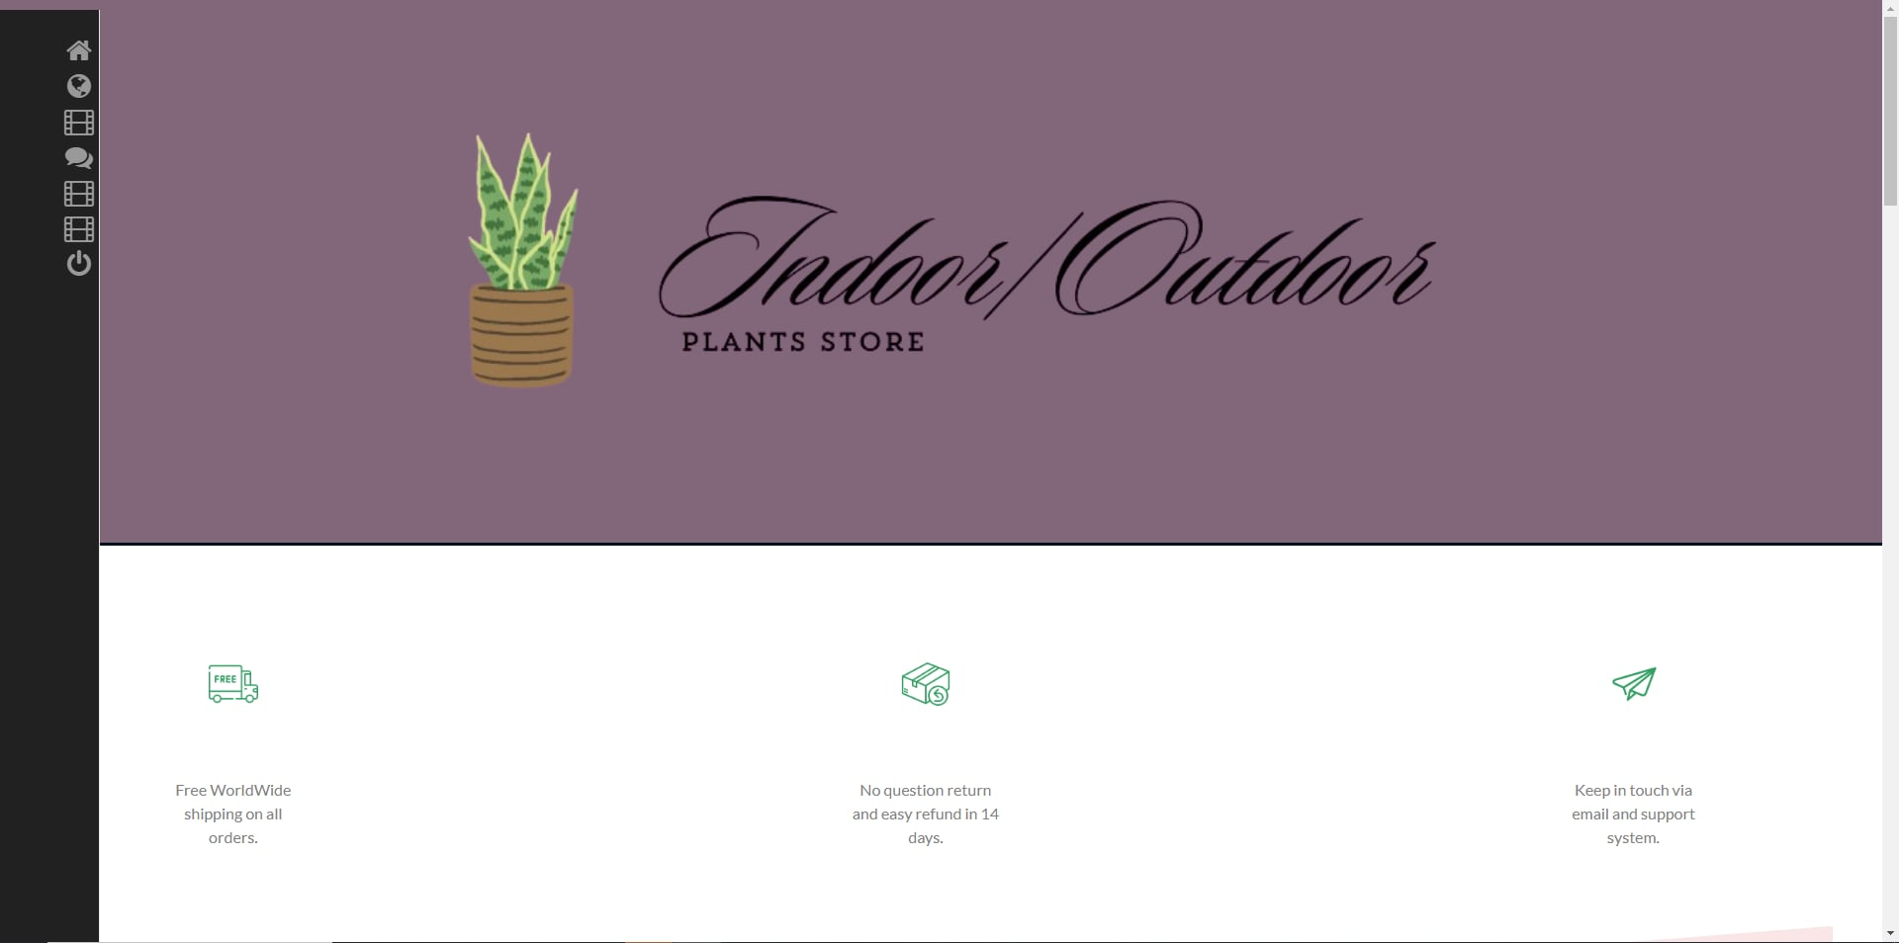

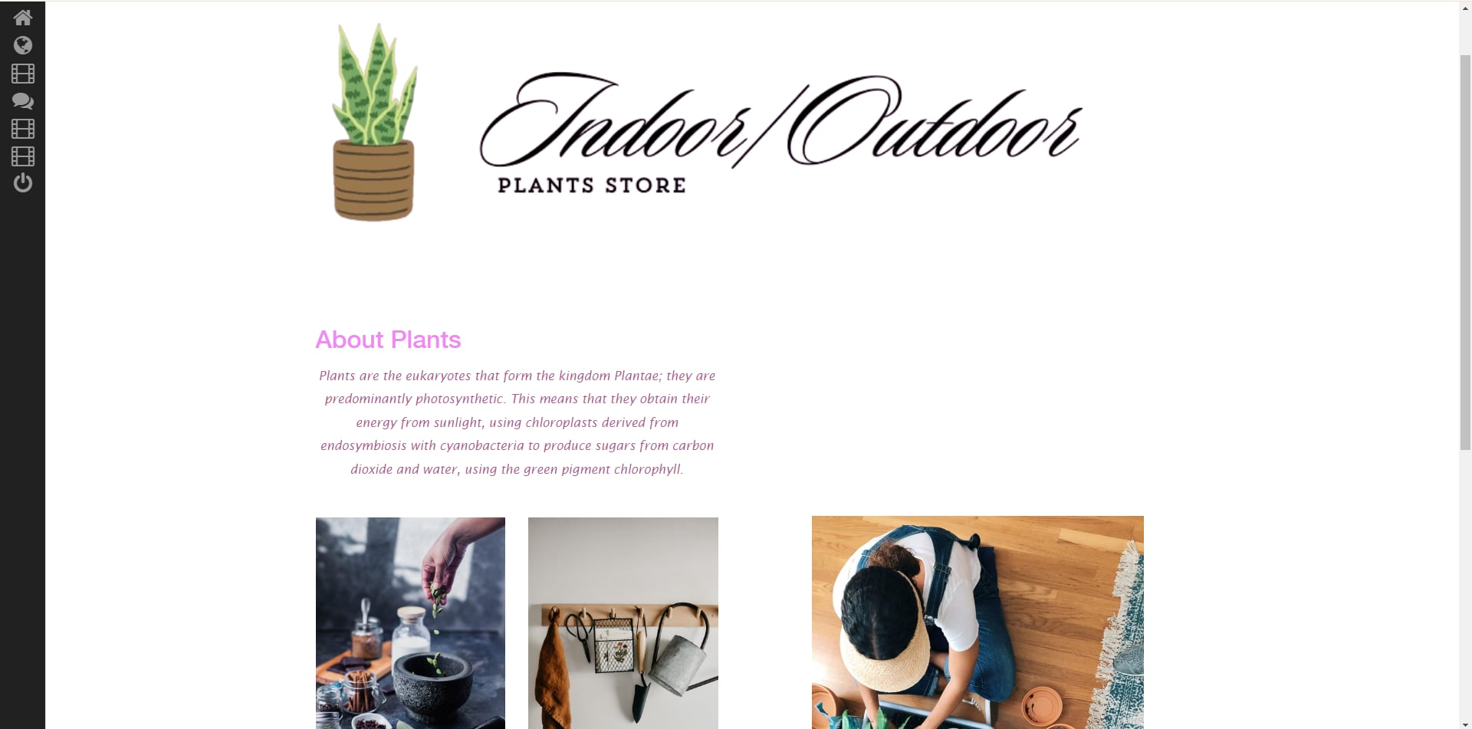

ABOUT

GALLERY

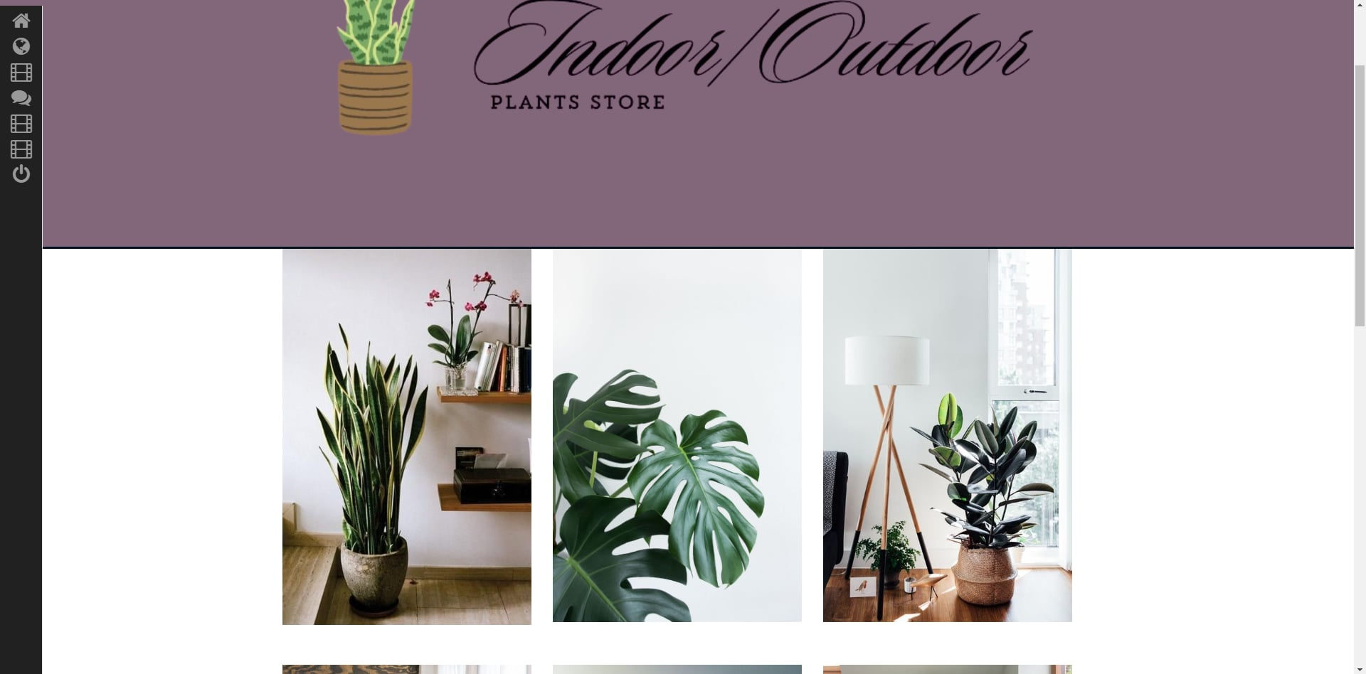

SERVICES

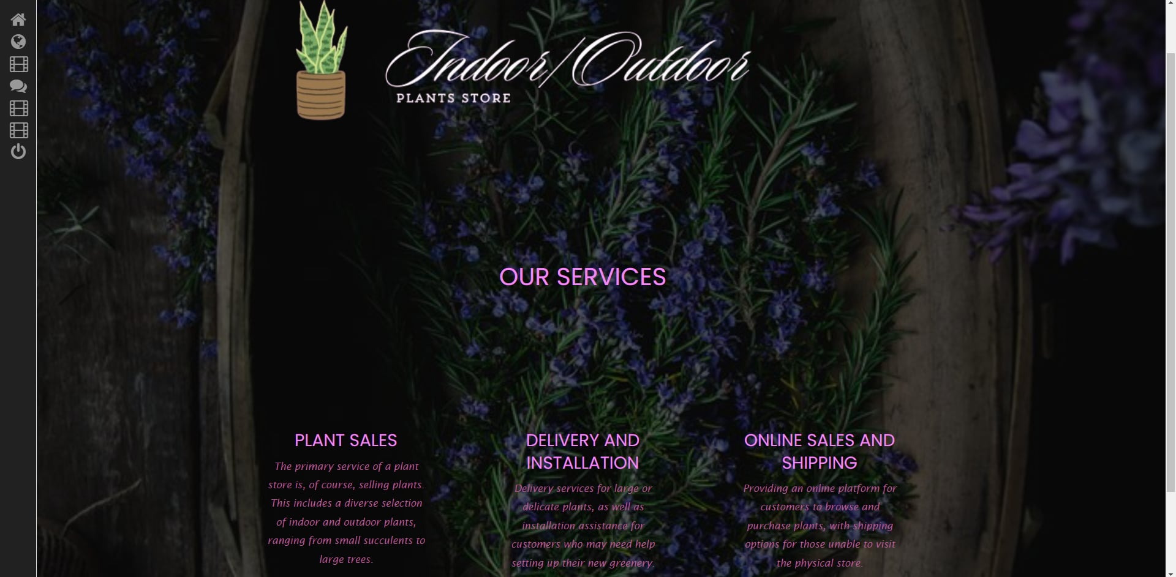

PROFILE

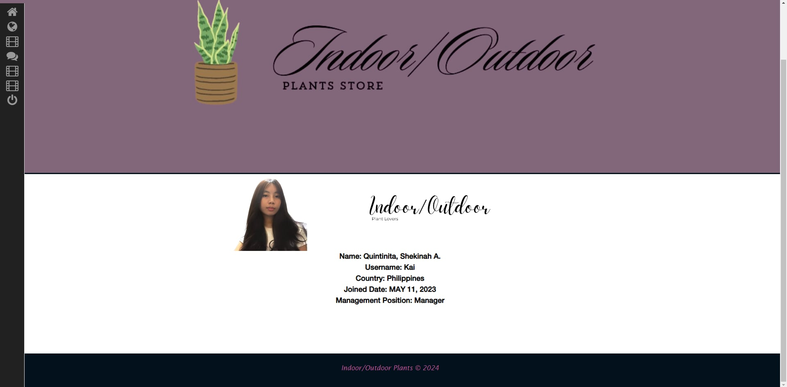

LOGOUT

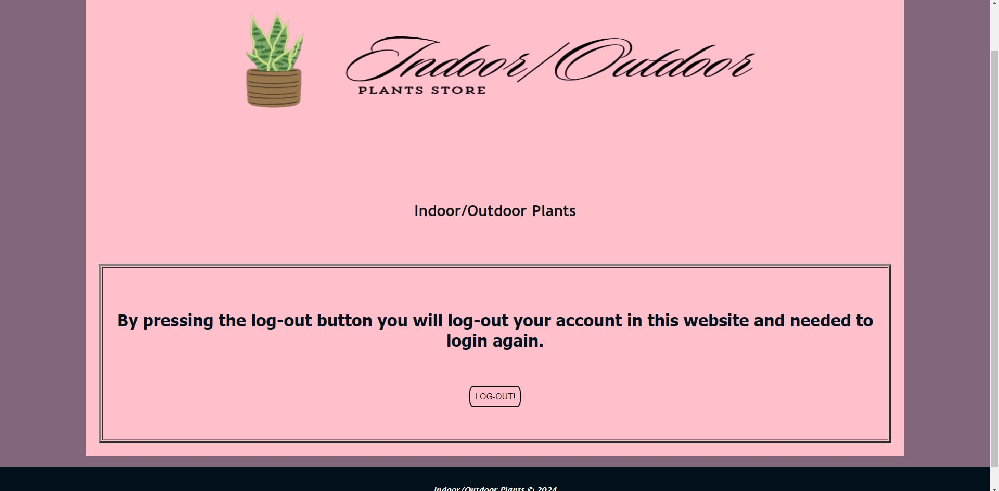

LOGIN

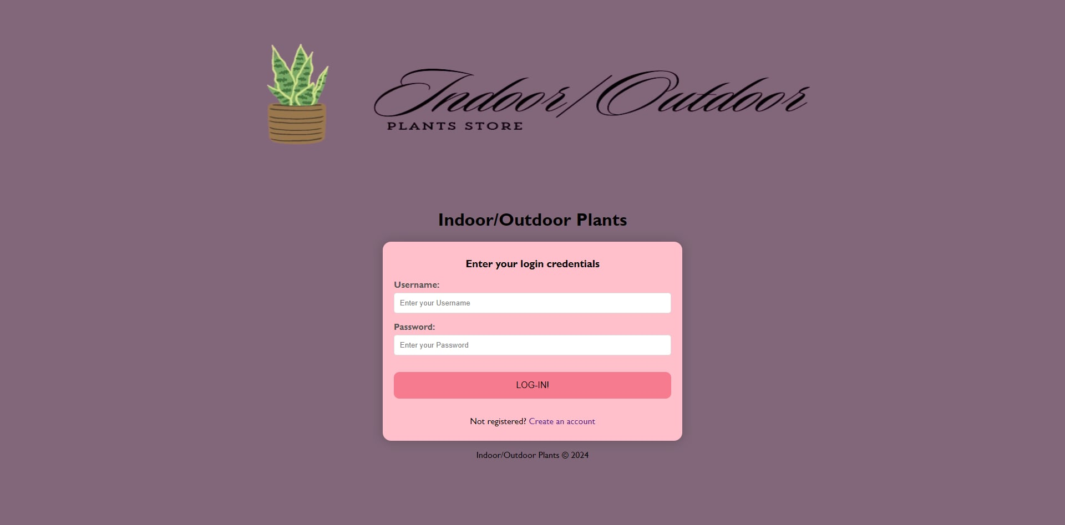

SHOP



REGISTER

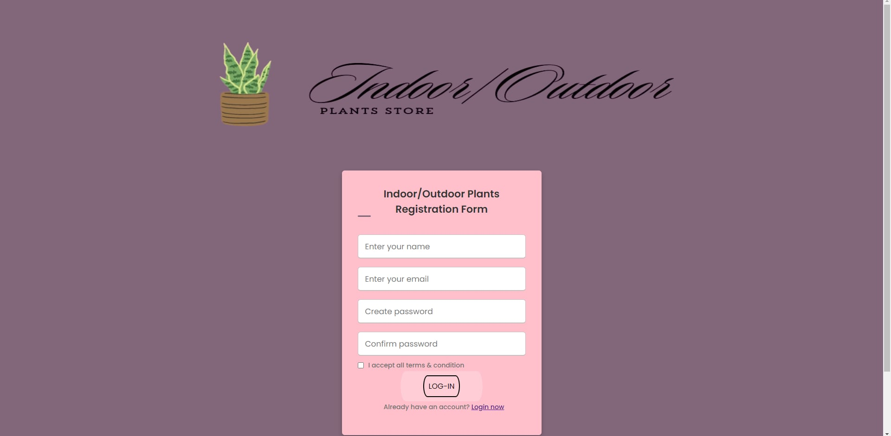

**TESTING**

**7.1 TEST PLAN**

**Project Title: Website Functionality Test**

Project Overview:

This test plan aims to ensure the functionality and usability of various features on the website, including marque, linking titles to messages, navigation buttons, image handling, form validation, account security, and aesthetics.

**Test Objectives:**

1. Verify the functionality of the marque feature in different directions and behaviors.
2. Confirm that school officials' titles are clickable links leading to their respective messages.
3. Test the forward and backward buttons for seamless navigation.
4. Ensure correct usage of image sources and proper alignment.
5. Validate the use of div elements to structure webpage content.
6. Verify that images are centered on the webpage.
7. Test form validation for blank inputs, invalid characters in usernames, and password complexity.
8. Confirm proper implementation of account security measures.
9. Verify the use of different fonts and colors for page identification and aesthetic enhancement.
10. Test Scope:
11. Test on various web browsers (Chrome, Firefox, Safari, etc.).
12. Test on different devices (desktop, mobile, tablet).
13. Test different scenarios for form validation (empty fields, invalid characters, etc.).
14. Test account security measures under different user scenarios (new account creation, password change, etc.).
15. Test different font and color combinations for aesthetic appeal.
16. Test Environment:
17. Hardware: Desktop, laptop, mobile devices.
18. Software: Web browsers (Chrome, Firefox, Safari), development tools for debugging (e.g., Chrome Developer Tools).
19. Network: Stable internet connection for online testing.
20. Test Strategy:
21. Manual testing for marque behavior and direction.
22. Manual testing to ensure school officials' titles are clickable and lead to the correct messages.
23. Manual testing of navigation buttons (forward and backward).
24. Manual and automated testing for image handling and alignment.
25. Manual testing of form validation for various scenarios.
26. Manual and automated testing for account security measures.
27. Manual testing of font and color combinations for aesthetics.

**Test Execution Schedule:**

* Marque Testing:
* Link Testing
* Navigation Button Testing
* Image Handling Testing:
* Form Validation Testing:
* Account Security Testing:
* Aesthetics Testing:

**Risks and Mitigation Strategies:**

**Risk:** Compatibility issues with certain browsers or devices.

**Mitigation:** Perform cross-browser and cross-device testing to identify and address compatibility issues.

**Reporting and Communication:**

Test results will be documented in a test report and shared with relevant stakeholders.

Regular updates on testing progress will be communicated via email or project management tools.

**Approval:**

**7.2 TEST CASES**

|  |  |
| --- | --- |
| Test Case | 01. Buttons |
| Test Objective | To test whether the buttons will work |
| Expected Results | The buttons should bring you to another web page |
| Actual Results | The buttons brought |
| Conclusion | Actual results matched expected results. |

|  |  |
| --- | --- |
| Test Case | 02 |
| Test Objective | To test whether the page will show you to the next page |
| Expected Results | Page should go forward |
| Actual Results | The page forwarded a single page |
| Conclusion | Actual results matched expected results. |

|  |  |
| --- | --- |
| Test Case | 03 |
| Test Objective | To test whether the page will bring you to the past page |
| Expected Results | Pages should go backward |
| Actual Results | The page backward a single page |
| Conclusion | Actual results matched expected results. |

|  |  |
| --- | --- |
| Test Case | 04 |
| Test Objective | To test whether the images will appear |
| Expected Results | Images should appear |
| Actual Results | The images appears |
| Conclusion | Actual results matched expected results. |

|  |  |
| --- | --- |
| Test Case | 05 |
| Test Objective | To test whether the div will do its function |
| Expected Results | Div should divide the page |
| Actual Results | The div worked |
| Conclusion | Actual results matched expected results. |

|  |  |
| --- | --- |
| Test Case | 06 |
| Test Objective | To put the text in the center of the webpage |
| Expected Results | Text should be in the center |
| Actual Results | The text is in the center |
| Conclusion | Actual results matched expected results. |

|  |  |
| --- | --- |
| Test Case | 07 |
| Test Objective | To test whether java script will react in blank usernames |
| Expected Results | Java script will prompt a message |
| Actual Results | Java script prompted “No blank please!” |
| Conclusion | Actual results matched expected results. |

|  |  |
| --- | --- |
| Test Case | 08 |
| Test Objective | To test whether java script will react in invalid character input in username |
| Expected Results | Java script will prompt a message |
| Actual Results | Java script reacted |
| Conclusion | Actual results matched expected results. |

|  |  |
| --- | --- |
| Test Case | 09 |
| Test Objective | To test whether an alert will prompt in insufficient characters |
| Expected Results | An alert will prompt |
| Actual Results | An alert prompted saying: “Password must contain at least 6 characters” |
| Conclusion | Actual results matched expected results. |

|  |  |
| --- | --- |
| Test Case | 10 |
| Test Objective | To test whether Java Script will react in the same password and username |
| Expected Results | Java script should prompt a message |
| Actual Results | Java script prompted, “Passwords should be different from usernames!” |
| Conclusion | Actual results matched expected results. |

|  |  |
| --- | --- |
| Test Case | 11 |
| Test Objective | To test whether Java Script will react in passwords composed of letters only |
| Expected Results | Alert will promt |
| Actual Results | An alert said, “password must contain at least one number!” |
| Conclusion | Actual results matched expected results. |

|  |  |
| --- | --- |
| Test Case | 12 |
| Test Objective | To test whether Java script will react to all capital letters in passwords |
| Expected Results | Java script will show an alert |
| Actual Results | An alert said, “password must contain at least one lower case letter!” |
| Conclusion | Actual results matched expected results. |

|  |  |
| --- | --- |
| Test Case | 13 |
| Test Objective | To test whether Java script will react to all small letters in passwords |
| Expected Results | Java script will show an alert |
| Actual Results | An alert said, “password must contain at least one uppercase letter!” |
| Conclusion | Actual results matched expected results. |

|  |  |
| --- | --- |
| Test Case | 14 |
| Test Objective | To test whether Java script will show a password confirmation |
| Expected Results | Java script should prompt an alert |
| Actual Results | An alert said, “You entered a valid password” |
| Conclusion | Actual results matched expected results. |

|  |  |
| --- | --- |
| Test Case | 15 |
| Test Objective | To test whether the texts are changing font styles |
| Expected Results | Text style should vary |
| Actual Results | The text font style varied |
| Conclusion | Actual results matched expected results. |

**USER GUIDE**

8.1 SYSTEM REQUIREMENTS

Quad Core processor and 64 bit RAM

8.2 USER MANUAL [**Graphical User Interface (GUI)]**

**Home:**

Functionality: Takes the user to the main landing page of the website.

Use Case: Allows users to easily navigate back to the homepage from any other page on the website.

**Gallery:**

Functionality: Leads users to a collection of images or multimedia content organized in a gallery format.

Use Case: Provides a visually engaging way for users to browse and view images, artwork, or other visual content.

**About Us:**

Functionality: Provides information about the website, its purpose, and mission.

Use Case: Helps users understand the background and context of the website, building trust and credibility.

**Profile:**

Functionality: Allows registered users to access their personal profile.

Use Case: Enables users to view and manage their account information, preferences, and activity.

**Log In:**

Functionality: Provides a means for users to authenticate and access their accounts by entering their username and password.

Use Case: Allows registered users to log in to their accounts to access personalized content, services, or features.

**Log Out:**

Functionality: Logs the current user out of their account, ending their session and returning them to a logged-out state.

Use Case: Enables users to securely log out of their accounts to protect their privacy and prevent unauthorized access.

**Services:**

Functionality: Offers information about the products, services, or solutions provided by the website or organization.

Use Case: Helps users understand the offerings available and how they can benefit from them.

**Register:**

Functionality: Allows new users to create an account by providing required information such as username, email, and password.

Use Case: Facilitates user registration and onboarding, granting access to additional features or content reserved for registered users.

**Videos:**

Functionality: Leads users to a collection of video content.

Use Case: Offers an interactive and engaging way for users to consume information or entertainment through video content.

**Activities:**

Functionality: Leads users to a collection of activities that has been made throughout the whole semester.

Use Case: Helps users to easily navigate and collect the activities that has been made.

**CONCLUSION**

**Scope:**

**Plant Variety**: The platform will offer a diverse range of indoor and outdoor plants, including but not limited to succulents, tropicals, flowering plants, herbs, and shrubs, catering to various preferences and environments.

**E-commerce Functionality**: The platform will feature e-commerce functionality, allowing customers to browse, select, and purchase plants and related products online, with options for delivery or pickup.

**Limitations:**

**Physical Constraints**: The platform's ability to offer certain plants may be limited by seasonal availability, supplier inventory, and shipping restrictions, which could impact the variety and availability of plants at any given time.

**Local Regulations**: Compliance with local regulations and restrictions regarding plant sales, shipping, and import/export may limit the platform's ability to serve customers in certain geographic regions or offer specific plant species.

**Plant Health Guarantee**: While Indoor/Outdoor Plants will take every precaution to ensure the health and quality of plants during transit and delivery, factors such as environmental conditions and handling during shipping may impact the condition of plants upon arrival, with limitations to our guarantee beyond delivery.

**Technical Limitations**: The functionality and performance of the platform may be subject to technical issues, such as server downtime, software bugs, or compatibility issues, which could affect the user experience and accessibility of the website.

**Expertise and Advice**: While Indoor/Outdoor Plants will strive to provide accurate and helpful advice and recommendations on plant care, the effectiveness of such guidance may vary depending on individual circumstances and factors beyond our control, such as local climate conditions and personal gardening practices.

**Environmental Factors**: The success of plant growth and health is influenced by various environmental factors, including but not limited to sunlight, temperature, humidity, and soil quality, which may vary significantly from one location to another and pose challenges for optimal plant care in certain environments.

**9.2 Program Strength**

**Diverse Plant Selection**: Indoor/Outdoor Plants offers a wide variety of indoor and outdoor plants, ensuring that customers can find the perfect green companions to suit their unique preferences and spaces.

**Personalized Recommendations**: Through interactive tools and personalized recommendations based on factors such as location, lighting conditions, and lifestyle, we help customers find plants that are well-suited to their specific needs and environments.

**Convenience and Accessibility**: Indoor/Outdoor Plants offers a seamless and convenient shopping experience, with easy online ordering, flexible delivery options, and responsive customer support, making it effortless for customers to bring the beauty of nature into their homes and gardens.

**Sustainability**: Indoor/Outdoor Plants is committed to sustainability, prioritizing eco-friendly practices throughout our operations, from responsible sourcing to waste reduction, helping to minimize our environmental footprint and promote a healthier planet for future generations.

**Quality Assurance**: We take pride in offering high-quality plants that are carefully selected and inspected to ensure optimal health and vitality, giving customers peace of mind knowing that they are receiving plants of the highest quality.

**Continuous Improvement**: Indoor/Outdoor Plants is dedicated to continuous improvement and innovation, regularly updating our offerings and services based on customer feedback and industry trends to ensure that we always deliver the best possible experience for our customers.

By leveraging these strengths, Indoor/Outdoor Plants aims to provide a comprehensive and enjoyable gardening experience that inspires and empowers customers to create thriving green spaces that enrich their lives and communities.

**9.3 Program Weakness**

**Limited Geographic Coverage**: Indoor/Outdoor Plants may have limited availability in certain geographic regions, potentially excluding customers who reside outside of our current service area.

**Seasonal Variability**: The availability of certain plants may be subject to seasonal fluctuations, leading to periods where specific plants are temporarily out of stock or unavailable.

**Shipping Constraints**: Shipping live plants can be challenging, and despite our best efforts to ensure safe delivery, factors such as transit times, handling, and environmental conditions during shipping may occasionally impact the health and condition of plants upon arrival.

**Technical Issues**: Like any online platform, Indoor/Outdoor Plants may experience occasional technical issues such as website downtime, slow loading times, or glitches, which could disrupt the user experience and affect customer satisfaction.

**Customer Service Constraints**: Despite our commitment to providing excellent customer service, our ability to address inquiries, resolve issues, and provide support may be limited during peak periods or due to resource constraints.

**Environmental Factors**: The success of plant care is heavily influenced by environmental factors such as sunlight, temperature, humidity, and soil quality, which may vary significantly from one location to another, posing challenges for customers in certain environments.

By acknowledging these weaknesses, we aim to continuously improve our services and address customer concerns to ensure a positive and fulfilling experience for all Indoor/Outdoor Plants customers.

**9.4 Enhancement**

**Expanded Geographic Coverage**: Indoor/Outdoor Plants could explore opportunities to expand its service area, reaching customers in new geographic regions and broadening its market reach.

**Seasonal Planning and Inventory Management**: Implementing a proactive approach to seasonal planning and inventory management can help Indoor/Outdoor Plants anticipate demand and ensure adequate stock availability for popular plants during peak seasons.

**Enhanced Shipping Protocols**: Investing in improved packaging materials, shipping methods, and tracking systems can help Indoor/Outdoor Plants mitigate the risks associated with shipping live plants, ensuring a smoother and more reliable delivery process.

**Website Optimization and Maintenance**: Regularly monitoring and optimizing the website's performance, addressing technical issues promptly, and investing in robust infrastructure can help Indoor/Outdoor Plants provide a seamless and enjoyable online shopping experience for customers.

By implementing these enhancements, Indoor/Outdoor Plants can strengthen its competitive position, improve customer satisfaction, and position itself as a leading destination for plant enthusiasts seeking quality plants and expert support.

**REFERENCE**

https://www.biologicaldiversity.org/species/plants/https://twitter.com/animehaikyu_com

https://www.ncbi.nlm.nih.gov/pmc/articles/PMC4844262/

<https://byjus.com/biology/plants/>

https://dictionary.cambridge.org/us/dictionary/english/plant

**APPENDIX**

**Appendix A: Glossary**

**Indoor Plants**: Plants that are cultivated and grown primarily indoors, typically in homes, offices, or other indoor spaces.

**Outdoor Plants**: Plants that are cultivated and grown primarily outdoors, such as in gardens, yards, or outdoor landscapes.

**Succulents**: Plants with fleshy, water-storing leaves or stems adapted to arid conditions, often characterized by their low water requirements and unique shapes and textures.

**Tropical Plants**: Plants native to tropical regions, known for their lush foliage, vibrant colors, and adaptability to warm and humid conditions.

**Herbs**: Plants cultivated for culinary, medicinal, or aromatic purposes, typically grown in gardens or containers for easy access and use.

**Shrubs:** Small to medium-sized woody plants with multiple stems and foliage, commonly used for landscaping and ornamental purposes.

**Appendix B: Plant Care Guides**

Detailed guides on watering schedules, sunlight requirements, soil types, and other care tips for a variety of indoor and outdoor plants.

Troubleshooting resources to help customers identify and address common plant problems, such as pests, diseases, and environmental stressors.

**Appendix C: Community Resources**

Links to online forums, social media groups, and community events where plant enthusiasts can connect, share tips, and exchange ideas.

Opportunities for customers to participate in contests, challenges, and virtual workshops hosted by Indoor/Outdoor Plants.

**Appendix D: Environmental Commitment**

Information on Indoor/Outdoor Plants' sustainability initiatives, including eco-friendly packaging, responsible sourcing practices, and carbon offset programs.

Tips and resources for customers to reduce their environmental footprint and practice sustainable gardening at home.

**Appendix E: Customer Testimonials**

Quotes and testimonials from satisfied customers highlighting their positive experiences with Indoor/Outdoor Plants, including feedback on product quality, customer service, and overall satisfaction.